III. North American Breeding Bird Survey (BBS) - https://www.pwrc.usgs.gov/BBS/: Lists of all historical records of breeding and migrant bird species detected at sample locations along a standard route. The BBS is a long-term, large-scale, international avian monitoring program initiated in 1966 to track the status and trends of North American bird populations. The US Geological Survey Patuxent Wildlife Research Center and the Canadian Wildlife Service National Wildlife Research Center jointly coordinate the BBS program. These are the same survey routes shown on the National Atlas site. Read about the survey on the homepage so you know when and how the data were collected. This information is called the metadata.

- To choose a survey route: On the BBS homepage click USGS Results and Analyses Route level analyses Click on your state Find the route that is closest to your hometown and record its number . If your hometown is not listed, go back to the National Atlas via the link, find the route closest to your hometown on a map, and record its number, then return to the BBS and continue. Note that you can get land cover information for your selected route on this BBS page also.

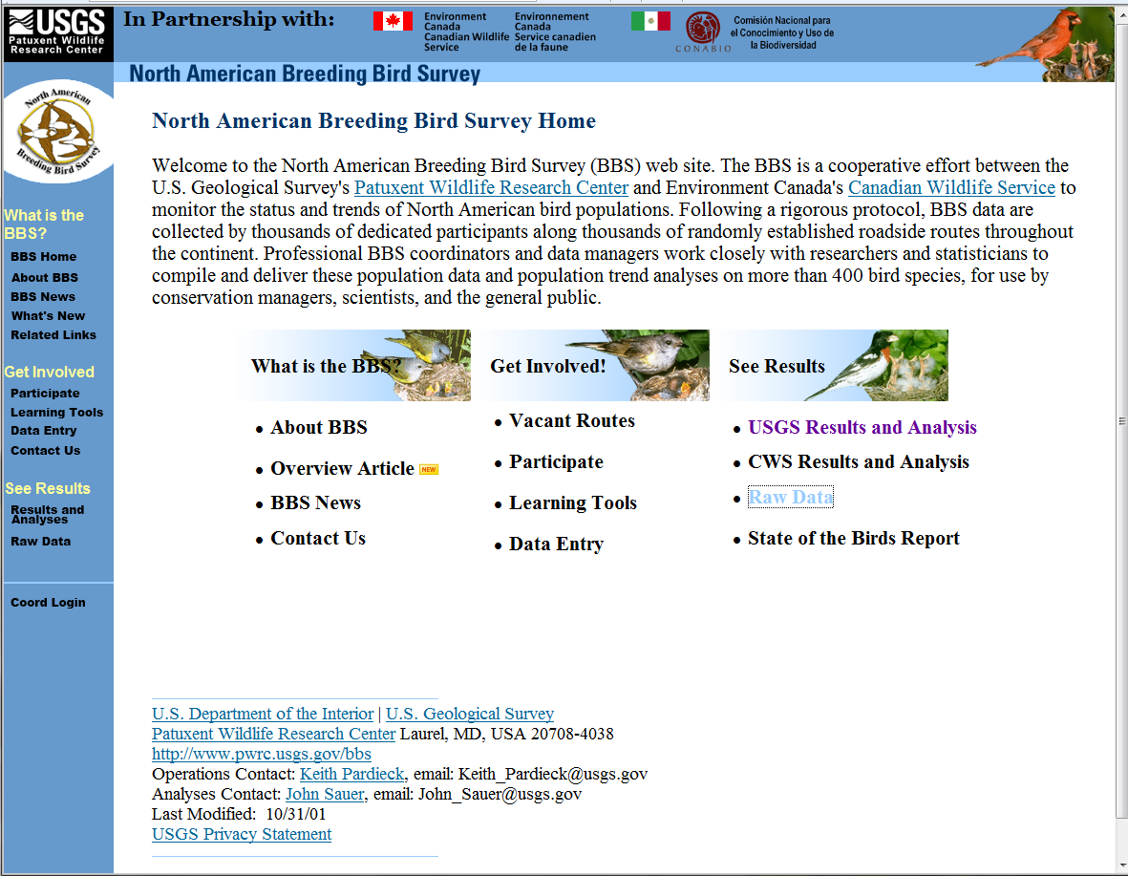

- To get species abundance data for download: Go back to the homepage Click on Raw Data Click Enter Retrieval System Scroll down and click Retrieve Raw Data Click on Species Totals for a Route

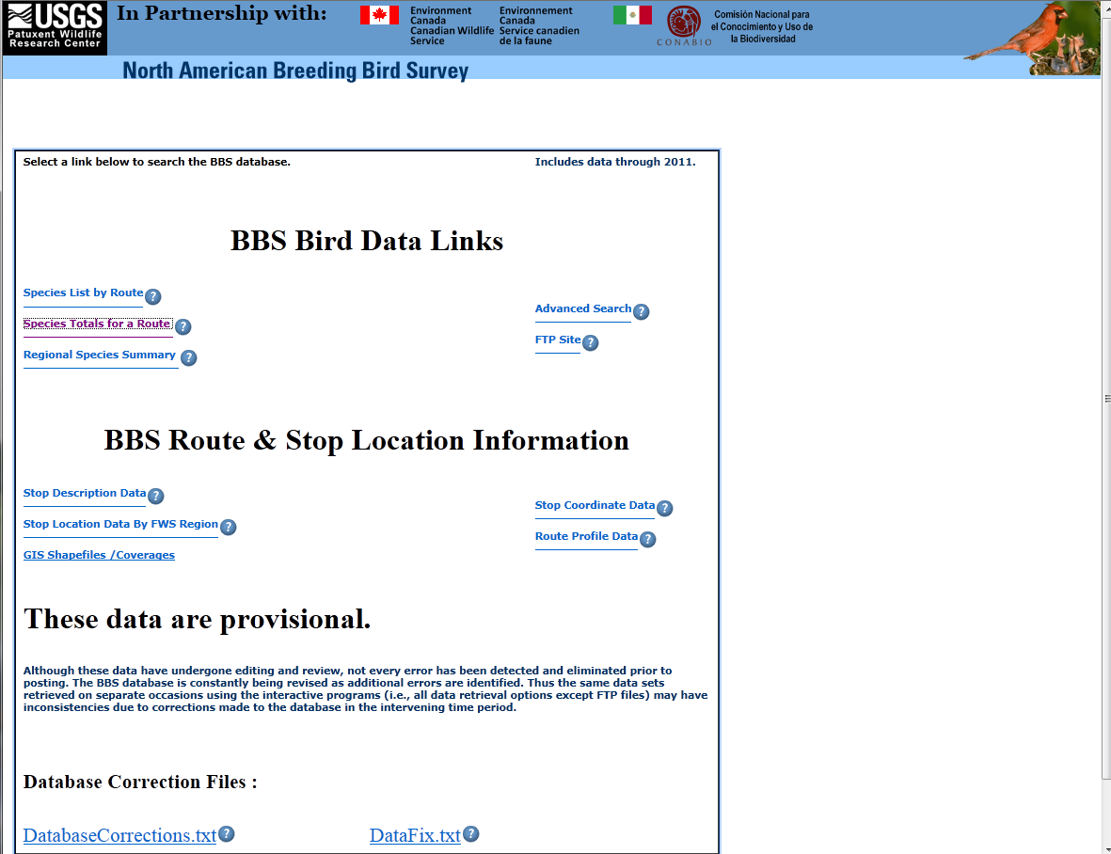

- Use the Country, Region, and Route pull-down menus to select the route you chose in the last step. Choose the Run Method (you might want to use the Standard BBS). Choose 1998 or earlier until the latest year in the year menus. (Why should you begin before the first year of the WNV invasion?) Download separate tables for breeding and migratory birds if you want to look at differences in migrants vs. year-round residents (breeding birds in the area). Use Phylogenetic or Alphabetic species order as indicated by your instructor. Which of the birds in your area are good hosts for WNV? Which species of birds are most susceptible to WNV?Do your data support the literature as to which species declined as WNV swept through your area?

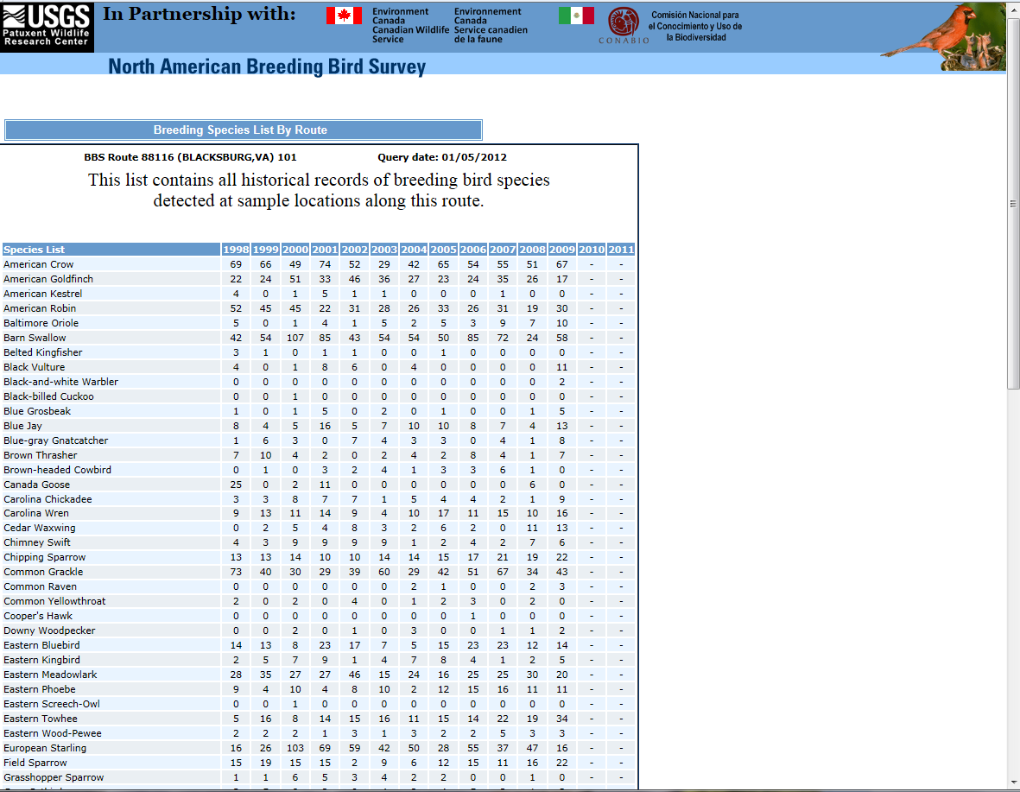

- Copy the resulting table into Excel.

- After downloading data for your local area, you will want to use it to calculate bird species diversity and evenness (richness is simply the total number of species present). There are several different indices for species diversity, each with its own strengths and weaknesses. An ideal index would discriminate clearly and accurately between samples, not be greatly affected by differences in sample size, and be relatively simple to calculate. Your instructor will tell you which index to use, may discuss using different indices for different kinds of data, and may ask you to calculate one not given here. See the Resource File “Species Diversity Calculations” (modified with permission from Beals et al. 1999, 2000) for a brief explanation of Simpson’s and Shannon’s Diversity Indices.

